**SQL ASSIGNMENT-7**

#### 1) Write an SQL query to show only odd rows from a table.

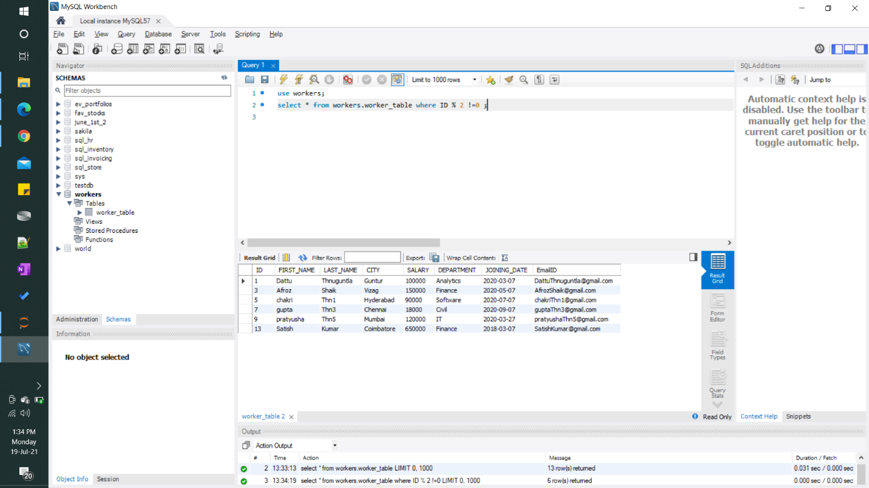

#### 2) Write an SQL query to clone a new table from another table.

